COVID 19 DECLARATION
EMPLOYEE DETAILS
Surname | First Name | Contact Number | Date of Birth
Home Address |  | Local Accommodation
PLEASE ASK THE BELOW QUESTIONS |  |  |  |  | YES | NO
Have you complied with all precautionary recommended Government Directives e.g. Social distancing, hand washing and respiratory etiquette?

Have you been in close contact* with anyone in the last 18 days that has experienced respiratory symptoms or a fever that would have you believe that they should/have be tested for COVID-19?

Have you experienced any symptoms listed below, within the last 18 days? (please note, runny nose is rare in COVID-19, only sometimes in influenza, is very common in general cold symptoms)
- Sore throat
- Dry cough
- Shortness of breath
- Fatigue (tiredness)
- Runny nose

Are you aware if you develop any of the above-mentioned symptoms, you should stay at home and advised your supervisor - so you can be seen by a Doctor before returning to work with a clearance medical certificate?

Do you have any other fitness for work concerns?

Please provide the attached hand out, prior to answering the below; |  |  |  |  | YES | NO
Have you received education around the prevention of spread of infectious diseases?

- Good hygiene practices, e.g. washing hands and/or use of alcohol-based hand rubs/ sanitisers?

- Respiratory etiquette, e.g. coughing into flexed elbow, using a tissue and placing into bin, washing hands?

- Social distancing of at least 1.5 metres? If your site work requires you to be in another person’s space, wear a respiratory face mask.

- Site cleaning expected standards, e.g. regular cleaning of frequently touched surfaces, doorhandles, stair rails and personal work areas, etc?

- Understanding that if you are sick stay at home, let your supervisor know where you are, and see a Doctor for further advice

Please provide your movements for the last 14 days;
Day | Location/Comments |  |  |  | Postcodes
1
2
3
4
5
6
7
8
9
10
11
12
13
14
15
16
17
18
PERSON DECLARING INFORMATION
Name |  |  | Signature | Date
SITE SUPERVISOR
Name |  |  | Signature | Date
 |  | PROVIDE THIS PAGE TO THE PERSON ENTERING WORK SITE
For the health and safety of all workers and the communities you are an invited essential worker too: please be courteous and adhere to the following.
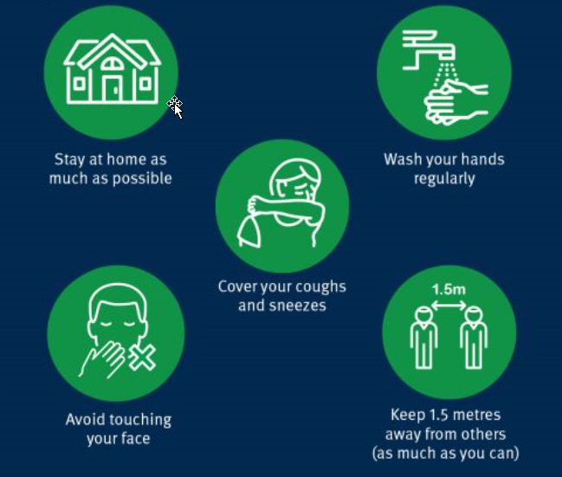
EXTRA CLEANING ON FREQUENTLY USED AREAS:
- Door handles
- Hand rails
- Lift buttons
- Surfaces
CLEANING OF PERSONAL WORKSPACES:
- Wipe down keyboards, mouses and phones
- Wipe down desk
- Wipe steering wheels after vehicle use (as applicable)
WHEN NOT AT WORK: Notice from 1 June 2020
- Residential Queenslanders are permitted to socialise and travel for recreational purposes within QLD borders, under the relaxing of restrictions.
- Essential workers with a residential address outside of QLD. Your border pass reflects permission to access QLD to travel to your location of work. You may access the goods and services provided within this location, to support your ability to attend work.

